**Number Systems Used In Computers**

Complete the following table:

|  |  |  |  |
| --- | --- | --- | --- |
| **Number System** | **Number Base** | **Digits Used** | **Purpose** |
| Decimal | Base 10 | 0 to 9 | Used for communicating with human users |
| Binary |  |  |  |
| Octal |  |  |  |
| Hexadecimal |  |  |  |

**Decimal vs. Binary System**

Write down the definition of a **Bit** in computer terminology:

Complete the following table:

|  |  |  |
| --- | --- | --- |
|  | **Decimal System** | **Binary System** |
| Uses Digits |  |  |
| Addition Examples |  |  |
| Powers of 10 |  |  |
| Evaluate 111 |  |  |

**Powers of 2**

|  |  |  |  |  |
| --- | --- | --- | --- | --- |
| **Power  of 2** | **Decimal Value** | **Integer Range** | **Number  of Bits** | **Computer Binary** |
| 21 | 2 | 0 - 1 | 1 | 0001 |
| 22 | 4 | 0 - 3 | 2 | 0011 |
| 23 |  |  |  | 0111 |
| 24 |  |  |  | 1111 |
| 25 |  |  |  | 0001 1111 |
| 26 |  |  |  | 0011 1111 |
| 27 |  |  |  | 0111 1111 |
| 28 | 256 | 0 - 255 | 8 | 1111 1111 |
| 29 |  |  |  | 0001 1111 1111 |
| 210 |  |  |  | 0011 1111 1111 |
| 211 |  |  |  | 0111 1111 1111 |
| 212 |  |  |  | 1111 1111 1111 |
| 213 |  |  |  | 0001 1111 1111 1111 |
| 214 |  |  |  | 0011 1111 1111 1111 |
| 215 |  |  |  | 0111 1111 1111 1111 |
| 216 | 65,535 | 0 – 65,534 | 16 | 1111 1111 1111 1111 |

**Conversions**

Convert the following binary numbers to decimal:

11 binary =

101 binary =

1010 binary =

Convert the following decimal numbers to binary:

6 decimal =

13 decimal =

**Binary Addition**

Add the following binary numbers. (verify your answers using decimal)

|  |  |  |  |  |  |  |  |  |  |  |  |  |  |
| --- | --- | --- | --- | --- | --- | --- | --- | --- | --- | --- | --- | --- | --- |
| |  |  | | --- | --- | | **0101** | **(decimal 5)** | | **+ 0010** | **(decimal 2)** | |  |  | | |  |  | | --- | --- | | **0101** | **(decimal 5)** | | **+ 1010** | **(decimal 10)** | |  |  | |
| |  |  | | --- | --- | | **0011** | **(decimal 3)** | | **+ 0010** | **(decimal 2)** | |  |  | | |  |  | | --- | --- | | **0110** | **(decimal 6)** | | **+ 0011** | **(decimal 3)** | |  |  | |

**Prefixes**

* Kilo (K) means __________________ Multiply by x______________
* Mega (M) means _________________ Multiply by x______________

* Giga (G) means __________________ Multiply by x______________
* Tera (T) means __________________ Multiply by x______________

**Examples**

1. 64 Kbps (Kilo-bits per seconds) = ___________________ bps (bits per second)
2. 256 Giga-bytes = _________________________________ bytes
3. 256 Giga-bytes = _________________________________ bits

**Computer Memory Structures**

|  |  |  |  |
| --- | --- | --- | --- |
| **Structure** | **Number of Bits** | **Largest Value** | **Used For...** |
| Bit |  |  |  |
| Byte |  |  |  |
| Word |  |  |  |
| Short Integer |  |  |  |
| Double Word |  |  |  |
| Long Integer |  |  |  |
| Memory Address |  |  |  |

**Memory Organization**

Bit (Binary Digit)

* One bit can have a value of ________ or _________
* Or a Boolean logic value of ________ or _________

|  |  |  |  |  |  |  |  |  |  |  |  |  |  |  |  |  |  |  |  |
| --- | --- | --- | --- | --- | --- | --- | --- | --- | --- | --- | --- | --- | --- | --- | --- | --- | --- | --- | --- |
| |  |  |  |  | | --- | --- | --- | --- | | 0 | 0 | 0 | 0 | | |  |  |  |  | | --- | --- | --- | --- | | 0 | 0 | 0 | 0 | | |  |  |  |  | | --- | --- | --- | --- | | 0 | 0 | 0 | 0 | | |  |  |  |  | | --- | --- | --- | --- | | 0 | 0 | 0 | 0 | |

Byte (8 bits)

* One byte has a size of ________ bits
* A byte has an unsigned integer value range from 0 to _________

|  |  |  |  |  |  |  |  |  |  |  |  |  |  |  |  |  |  |  |  |
| --- | --- | --- | --- | --- | --- | --- | --- | --- | --- | --- | --- | --- | --- | --- | --- | --- | --- | --- | --- |
| |  |  |  |  | | --- | --- | --- | --- | | 0 | 0 | 0 | 0 | | |  |  |  |  | | --- | --- | --- | --- | | 0 | 0 | 0 | 0 | | |  |  |  |  | | --- | --- | --- | --- | | 0 | 0 | 0 | 0 | | |  |  |  |  | | --- | --- | --- | --- | | 0 | 0 | 0 | 0 | |

Word (2 bytes or 16 bits)

* One word has a size of ________ bits
* One word has a size of ________ bytes
* A byte has an unsigned integer value range from 0 to _________

|  |  |  |  |  |  |  |  |  |  |  |  |  |  |  |  |  |  |  |  |
| --- | --- | --- | --- | --- | --- | --- | --- | --- | --- | --- | --- | --- | --- | --- | --- | --- | --- | --- | --- |
| |  |  |  |  | | --- | --- | --- | --- | | 0 | 0 | 0 | 0 | | |  |  |  |  | | --- | --- | --- | --- | | 0 | 0 | 0 | 0 | | |  |  |  |  | | --- | --- | --- | --- | | 0 | 0 | 0 | 0 | | |  |  |  |  | | --- | --- | --- | --- | | 0 | 0 | 0 | 0 | |
|  | |  | |

Long or Double Word (4 bytes or 32 bits)

* One Long word has a size of ________ words
* A Long word has an unsigned integer value range from 0 to _________

|  |  |  |  |  |  |  |  |  |  |  |  |  |  |  |  |  |  |  |  |
| --- | --- | --- | --- | --- | --- | --- | --- | --- | --- | --- | --- | --- | --- | --- | --- | --- | --- | --- | --- |
| |  |  |  |  | | --- | --- | --- | --- | | 0 | 0 | 0 | 0 | | |  |  |  |  | | --- | --- | --- | --- | | 0 | 0 | 0 | 0 | | |  |  |  |  | | --- | --- | --- | --- | | 0 | 0 | 0 | 0 | | |  |  |  |  | | --- | --- | --- | --- | | 0 | 0 | 0 | 0 | |
|  | |  | |
| |  |  |  |  | | --- | --- | --- | --- | | 0 | 0 | 0 | 0 | | |  |  |  |  | | --- | --- | --- | --- | | 0 | 0 | 0 | 0 | | |  |  |  |  | | --- | --- | --- | --- | | 0 | 0 | 0 | 0 | | |  |  |  |  | | --- | --- | --- | --- | | 0 | 0 | 0 | 0 | |
|  | |  | |

**Questions**

1. What is the smallest memory object that can represent a character of information?
   1. Think… How many upper case letters in the alphabet (A to Z)?
      1. There are 26 Capital letters in the alphabet.
   2. Think… How many lower case letters in the alphabet (a to z)?
      1. There are 26 lower case letters in the alphabet.
   3. Think… How many number digits (0 to 9)?
      1. There are 10 number digits in the memory system.
   4. Think… How many punctuation marks?
      1. There are 14 types of punctuations in the computer memory.
   5. Add them all up
      1. There are up to 130 different memory objects in the computer.
2. Research the ASCII characters set. What is it and how is it related to computer memory?
   1. The ASCII character set is a set of computer data that utilizes numeric codes that range from 0 to 27. The most utilized method is the American Standard Code for Information Interchange (ASCII), it is the crucial method used to communicate between computers using the binary system with each letter or character representing one byte or 8 bits.
3. How are strings of characters (Google “String”) represented in computer memory?
   1. Each are represented in the form of bytes, each 8 or 7 bits long represents or stores letters and characters.
4. How are negative integers represented in computer memory? (Include a diagram)
   1. They are represented by the left most bit as the sign of the number, 0 presents a positive value and a 1 is a negative value.

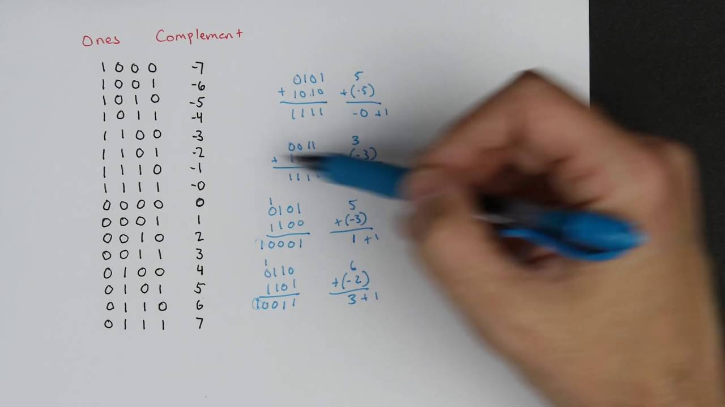

1. How are decimal numbers (Google “Floating Point”) represented in computer memory? (Include a diagram)
   1. Decimal numbers are stored in computer memory by turning these numbers into a scientific notation, this allows the numbers to be extremely large, but limits their precision numbers. Another method is converting the number to 4 bytes of which 1 is used for the sign, 8 are used for the exponent, and the other 23 for the mantissa.

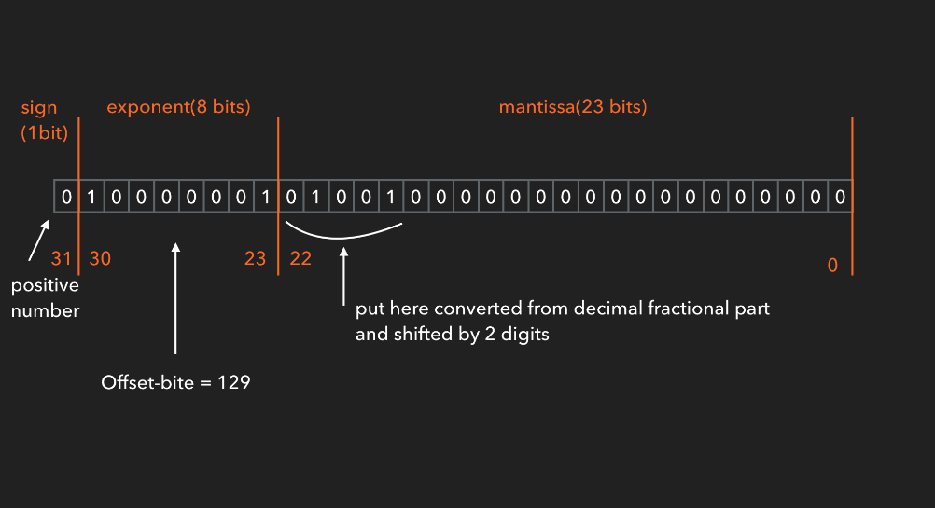

1. A Pixel is computer memory structure used to store image information. How is a Pixel represented in memory? (Include a diagram).
   1. Each pixel is used to present either the colours of red, green or blue. The binary code inside each pixel translates to the hex code of the colour on the pixel, this is how pictures are stored, and why they take up so much space.

